|  |
| --- |
| Productio |
| Analysis document |
|  |

|  |
| --- |
| Sjoerd Halmans  25-2-2021 |

Inhoud

Preface 2

Project explanation 3

MoSCoW – Functional requirements 4

Must haves 4

Should haves 4

# Preface

In semester six we have been tasked with making an enterprise software system. In this document I will explain my idea for the project, write up a few requirements, and use some different diagrams to further explain my vision for the project.

# Project explanation

The project I have chosen to make is called ‘Productio’, it will be an online SPA that functions as a central dashboard for a fictive company. A wide range of different employees with different clearance levels will be able to login to the application and use it’s functions, depending on their clearance they will be able to interact with different modules in different ways. (e.g. different departments might be allowed to read HR reports but only HR may write up new reports.)

This will allow the company to have all of it’s data in a singular system and easily share it between different departments and make sure no complex connections have to be made between the different systems used by departments to store/use data.

# MoSCoW – Functional requirements

## Must haves

**FR.01** A guest must be able to create an account to become a standard user.

**FR.02** A user must be able to manage their own account. (CRUD)

**FR.03** A requisitions user must be able to order raw materials.

**FR.04** A requisitions user must be able to read requisition requests from other departments

**FR.05** A requisitions user must be able to approve and deny requisition requests.

**FR.06** An HR user must be able to write up an HR report.

**FR.07** An HR user must be able to read an HR report.

**FR.08** An HR user must be able to manage job openings.

**FR.09** An HR user must be able to manage users and their clearance levels.

**Constraint.09.01** A HR user can not manage their own clearance level.

**FR.10** A Sales user must be able to view different sales numbers.

**FR.11** A Sales user must be able to create different visualizations using sales numbers.

**FR.12** A Sales user must be able to write up reports and let other departments read them.

**FR.13** A Production user must be able to start a production line.

**Constraint.13.01** This can only be done if the logistics department has ordered the needed materials

**FR.14** A production user must be able to send a requisitions request.

**FR.15** A production user must be able to assign a production line to a specific product.

**FR.16** A production user must able to view production line status.

**FR.17** A logistics user must be able to assign transports to delivering raw materials.

**FR.18** A logistics user must be able to write reports to HR requesting more drivers.

**FR.19** A logistics user must be able to send a requisitions request for new vehicles.

**FR.20** A logistics user must be able to set up repeating transports.

## Should haves

**FR.21** A user must be able to view the web shop.

**FR.22** A user must be able to purchase items in the web shop.

**FR.23** A user must be able to apply for a position in the company.

**FR.24** A user must be able to find news stories about the company.

**FR.25** A user must be able to sign up for workshops from the company.

## Could haves

**FR.26** A user must be able to subscribe to notifications about job offers.

**FR.27** A user must be able to choose to be notified if a workshop is coming up.

**FR.28** A user must be able to choose to be notified about posts made by the company.

# Use case diagram

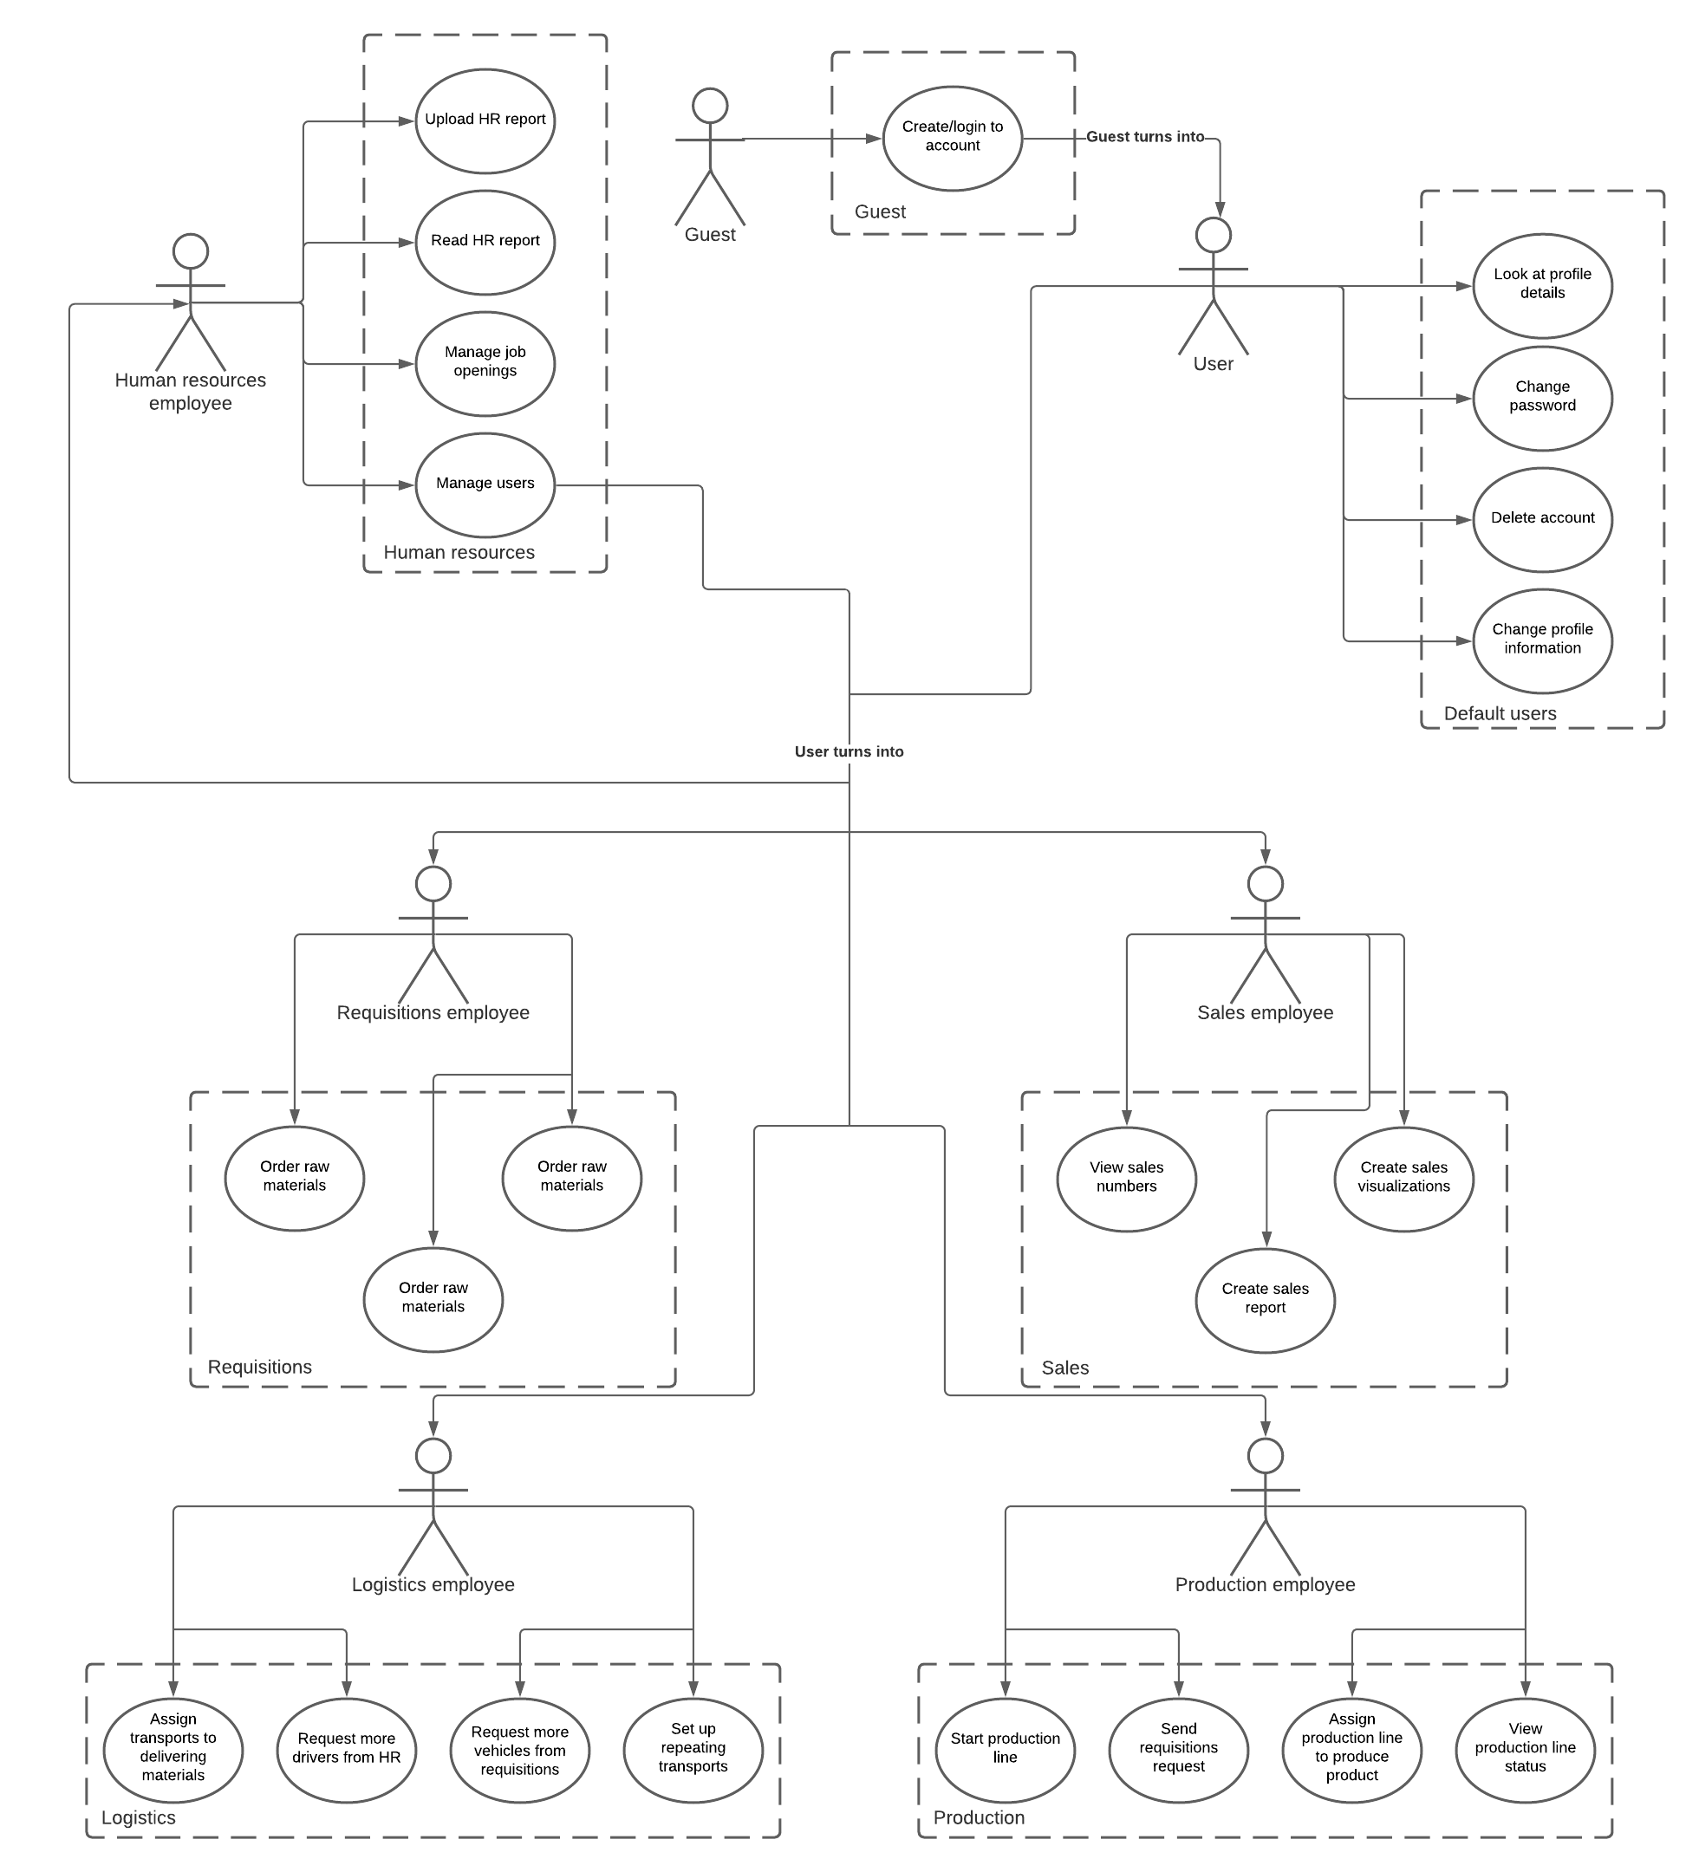In this chapter I will explain the use case diagram you can see below.

In the use case diagram we have seven kinds of users in total. This diagram was made to visualize permissions for myself so it will be easier for me to set up the clearance levels when developing the application. Each actor has a few actions they can do, a special action that the human resource employee can do, is change the permissions a user has. This allows them to change what that user can do within the application.

The rest of the diagram is best explained by looking at it. The bubbles connected to an actor are the actions that they will be able to do within the application.